CHECKLIST
For assessing IMI2 JU eligibility for funding of companies having an annual turnover of EUR 500 million or less
Organisation legal name

Organisation PIC Number (from the Participant register/Funding & tenders portal)

Version 05/06/2020

The objective of this checklist is to determine whether an organisation qualifies as a participant eligible for IMI2 JU funding, as defined in IMI2 JU Delegated Regulation (EU) 622/2014.

The checklist must be filled in by private for profit legal entities - intending to receive IMI2 JU funding as a Beneficiary Receiving Funding (BRF) - that are not SMEs according the Commission Recommendation 2003/361/EC of 6 May 2003 (concerning the definition of micro, small and medium-sized enterprises), and therefore not susceptible to be validated as such in the Participant register / Funding & tenders portal (i.e. entities that do not qualify as an SME). In case of doubt on whether your company qualifies as an SME, you may first fill-in the SME self-assessment questionnaire in the Funding & tenders portal.

In the context of IMI2 JU Article 1(b)(i) of Delegated Regulation (EU) 622/2014, in order to be eligible for funding, private for profit legal entities – i.e. companies – must have an annual turnover of EUR 500 million or less, not being affiliated entities of companies with an annual turnover of more than 500 million.

The definition of ‘affiliated entities’ is provided by Article 2(1)(2) of Regulation (EU) No 1290/2013:
'Affiliated entity' means any legal entity that is under the direct or indirect control of a participant, or under the same direct or indirect control as the participant, or that is directly or indirectly controlling a participant.

Steps for the assessment of eligibility for funding

Private for profit legal entity participating in an IMI2 JU project

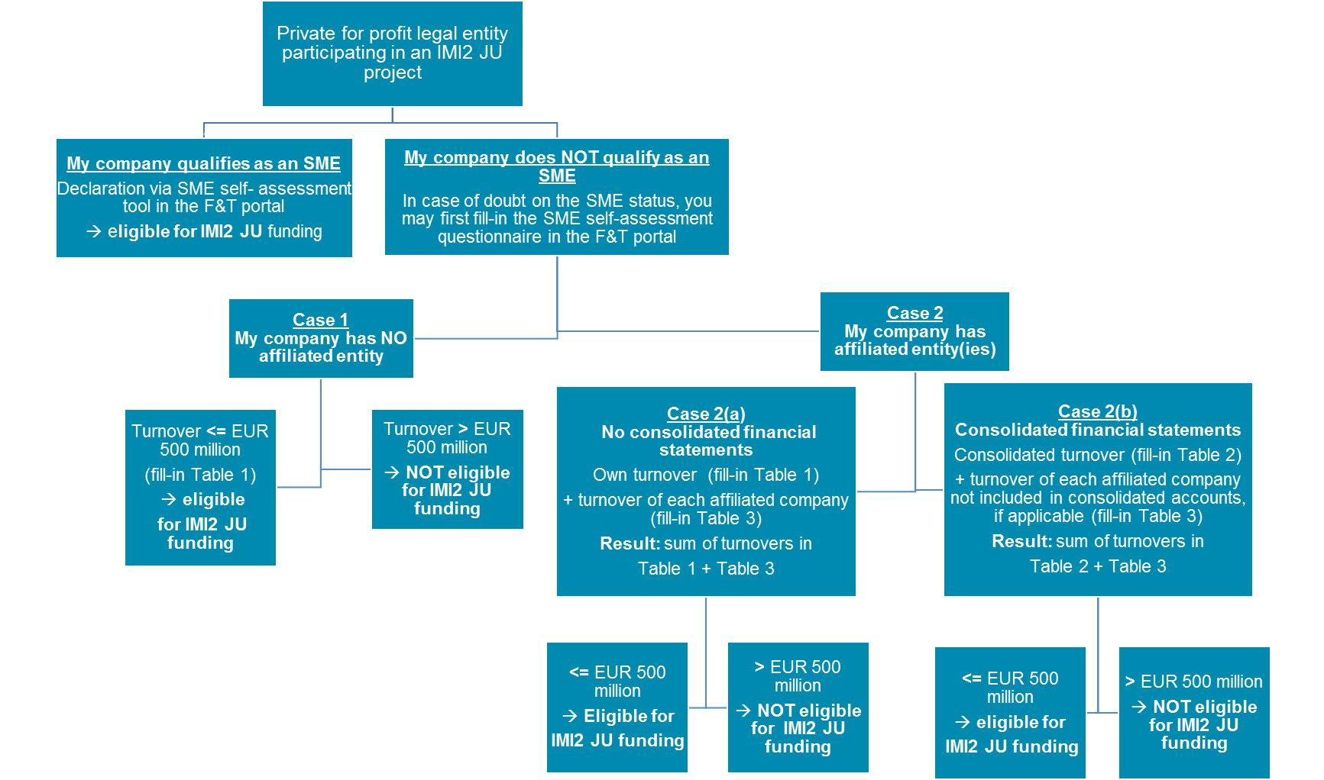

Explanations of decision tree above -cases 1, 2(a) and 2(b)

Case 1: Your organisation has NO affiliated entity

This is the case where your organisation has no affiliated entity in the sense of:
- no parent company, subsidiary company, company under the same control, or
- any other company exercising control on your company in fact or in law or any other form of control; or
- any other company under control of your company in fact or in law or any other form of control.

Your organisation needs to fill in Table 1, based on the last approved financial statements:
Own annual turnover  <= EUR 500 million | Own annual turnover  > EUR 500 million
Eligible for IMI2 JU funding | Not eligible for IMI2 JU funding

Case 2: Your organisation has affiliated entity(ies)

Case 2(a): Your organisation does not draw up consolidated financial statements

Your organisation does not draw up consolidated financial statements or is not included in the consolidated financial statement of another company.
In this case, your organisation needs to declare its own turnover (Table 1) and the turnover of any affiliated entity in the sense of parent company, subsidiary company, company under the same control, or any other company exercising control on your company or any other company under control of your company, in fact or in law or any other form of control (Table 3).

Your organisation needs to fill in Table 1 and Table 3, on the basis of the last approved financial statement of your organisation and its affiliated entities:

Own annual turnover (Table 1)  + turnover of each affiliated company  (Table 3)  <= EUR 500 million | Own annual turnover (Table 1)  + turnover of each affiliated company (Table 3)  > EUR 500 million
Eligible for IMI2 JU funding | Not eligible for IMI2 JU funding

Case 2(b): Your organisation draws up consolidated financial statements

Your organisation draws up consolidated financial statements or is included in the consolidated financial statements of another company.

In this case, your organisation needs to declare the consolidated turnover, your organisation must indicate the consolidated turnover specified in the consolidated financial statements, independently of its position as a subsidiary or a parent company (Table 2).

Furthermore, your organisation also needs to declare, if any, the turnover of any other company NOT already included in the consolidated financial statement exercising control on your company, under control of your company, or under the same control. Control can be in fact, in law or in any other form (please see Table 3).

Your organisation needs to fill in Table 2 and Table 3 on the basis of the relevant companies last approved financial statements.

Consolidated annual turnover (Table 2)  + turnover of each affiliated company not consolidated (Table 3), if applicable  <= EUR 500 million | Consolidated annual turnover (Table 2)  +turnover of each affiliated company not consolidated (Table 3), if applicable  > EUR 500 million
Eligible for IMI2 JU funding | Not eligible for IMI2 JU funding

TABLE 1 - Declaration on the company’s own turnover

Table to fill in if your organisation has no consolidated financial statements

- The duration (in months) of your last approved accounting period. All  data must be calculated on an annual basis.  In the case of newly-established enterprises whose accounts have not yet been approved, the data to apply shall be derived from a reliable estimate made in the course of the financial year. | Months
- The closing date (dd/mm/yyyy) of your last approved accounting period.  All data must be relating to the last approved accounting period. | Date
- The annual turnover of your organisation participating in the IMI2 JU grant/proposal (in EUR)* | EUR (*)
4. Name and signature of the authorised legal representative of your organisation participating in the IMI2 JU grant/proposal.
*Official exchange rate at the day of the closure of the accounting period: http://ec.europa.eu/budget/inforeuro

Table 2 - Declaration on consolidated turnover

Table to fill in when your organisation has affiliated companies which altogether draw up consolidated financial statements

1. The duration (in months) of your last approved accounting period. All data must be calculated on an annual basis.  In the case of newly-established enterprises whose accounts have not yet been approved, the data to apply shall be derived from a reliable estimate made in the course of the financial year. | Months
2. The closing date (dd/mm/yyyy) of your last approved accounting period.  All data must be relating to the last approved accounting period. | Date
3. The non-consolidated annual turnover of your organisation participating in the IMI2 JU grant/proposal (in EUR)* | EUR (*)
4. The consolidated annual turnover from the consolidated financial statements, of the ultimate parent company (in EUR)*, when your company (whether your company is a parent company or a subsidiary) draws up consolidated financial statements or is included in another company’s consolidated financial statements.
Please submit a copy of those financial statements together with this checklist.
Name and signature of the authorised legal representative of your organisation participating in the IMI2 JU grant/proposal.
*Official exchange rate at the day of the closure of the accounting period: http://ec.europa.eu/budget/inforeuro

Table 3 - Declaration on affiliated companies not included in consolidated financial statements
In case of affiliated entities whose turnover is not included in consolidated financial statements, the overall annual turnover needs to be calculated as well.

Therefore, please introduce into the Table 3 only affiliated companies fulfilling the following conditions:
- They are not included in the consolidated financial statements of Table 2,
- They are affiliated entity in the sense of:
- parent company, subsidiary company, company under the same control, or
- any other company exercising control on your company in fact or in law or any other form of control, or
- any other company under control of your company in fact or in law or any other form of control.

To verify point b), please check whether your organisation is in any of the following cases:

- Your organisation is controlled by another company(ies)  - An enterprise has the direct or indirect holding of more than 50 % of the nominal value of the issued share capital, or of a majority of the voting rights of the shareholders or associates in your organisation.  - An enterprise has the direct or indirect holding, in fact or in law, of decision making powers in your organisation, for instance:  - has the right to appoint or remove a majority of the members of the administrative, management or supervisory body of your organisation; or  - has the right to exercise a dominant influence over your organisation pursuant to a contract entered into with you or to a provision in a memorandum or articles of association; or  - is a shareholder in or a member of your organisation, and controls alone, pursuant to an agreement with other shareholders in or members of your organisation, a majority of shareholders' or members' voting rights in your organisation.  - An enterprise exercises any other form of control, in fact or in law, on your organisation. | [Yes or No]
If yes, please fill in table 3.A

- 2. Your organisation controls another company(ies)  - Your organisation has the direct or indirect holding of more than 50 % of the nominal value of the issued share capital, or of a majority of the voting rights of the shareholders or associates of another enterprise;  - Your organisation has the direct or indirect holding, in fact or in law, of decision making powers in another enterprise, for instance:  - has the right to appoint or remove a majority of the members of the administrative, management or supervisory body of the other enterprise; or  - has the right to exercise a dominant influence over the other enterprise pursuant to a contract entered into with you or to a provision in a memorandum or articles of association; or  - is a shareholder in or a member of another enterprise, and controls alone, pursuant to an agreement with other shareholders in or members of the other enterprise, a majority of shareholders' or members' voting rights in the other enterprise.  - Your organisation exercises any other form of control, in fact or in law, on another enterprise. | [Yes or No]
If yes, please fill in table 3.B

3. Another enterprise is under the same direct or indirect control as your organisation, e.g.:  - via the same natural person(s) involved in the ownership and/or the management of your organisation and another enterprise; and your organisation and this enterprise operates in the same or adjacent markets (i.e. the market for a product or service situated directly upstream or downstream of the relevant market).  - via the same company having a direct or indirect holding of more than 50 % of the nominal value of the issued share capital or a majority of voting rights of the shareholders or associates of your organisation and another enterprise. | [Yes or No]
If yes, please fill table 3.C

If according to your answers to the preceding questions, your organisation has affiliated companies not included in your consolidated financial statements, the following data for their last approved accounting period must be provided for each of them:

Table 3.A Affiliated parent companies

Legal name of the enterprise | a) Share in the capital of your organisation | b) Share in the voting rights of your organisation | Annual Turnover  based on last approved accounts  in EUR
 | (2) | (3) | (4)
 |  |  | Total (*):
* Turnover of public entities or venture capital firm should not be taken into account

Table 3.B Affiliated subsidiaries
Legal name of the enterprise | a) Your organisation share in the capital of the subsidiary | b) Your organisation share in the voting rights of the subsidiary | Annual Turnover  based on last approved accounts  in EUR
 | (2) | (3) | (4)
 |  |  | Total:

Table 3.C Affiliated enterprise(s) under the same control or other or any other company exercising control on your company or any other company under control of your company
Legal name of the enterprise | Annual Turnover  based on last approved accounts  in EUR
 | (2)
 | Total:

Result tables 3 = Total 3.A + Total 3.B + Total 3.C in EUR

Result for the assessment of IMI2 JU eligibility for funding

 | Case 1  Companies with  no affiliates | Case 2 - Companies with affiliates
 |  | Case 2a  Companies without consolidated financial statements | Case 2b  Companies with  consolidated financial  statements
Table 1  Own annual turnover of the legal entity participating in the IMI2 JU grant/proposal (in EUR) | [Enter turnover  of Table 1] | [Enter turnover  of Table 1] | n/a
Table 2  The consolidated annual turnover (from the consolidated financial statements), according to the information provided in Table 2, from the ultimate parent company (in EUR) | n/a | n/a | [Enter consolidated turnover of Table 2]
Table 3  Affiliated companies not included in consolidated financial statements |  | [Enter total of Table 3;  if applicable] | [Enter total of Table 3;  if applicable]
Total in EUR | [Enter total of  Table 1] | [Enter sum of  Table 1 and Table 3] | Enter sum of  Table 2 and Table 3]

Name of the authorised legal representative of your organisation participating in the IMI2 JU grant/proposal.
Signature of the authorised legal representative of your organisation participating in the IMI2 JU grant/proposal.

Annex – IMI2 JU Legal framework
Article 1 of the Commission Delegated Regulation No 622/2014
By way of Derogation from Article 10.1 of H2020 Regulation (EU) No 1290/2013, with regard to the Innovative Medicines Initiative 2 Joint Undertaking, only the following participants are eligible for IMI2 JU funding:

- Independent legal entities established in a Member State or an associated country, or created under Union law; and which are
- micro, small and medium-sized enterprises and other companies with an annual turnover of EUR 500 million or less, the latter not being affiliated entities of companies with an annual turnover of more than 500 million; the definition of ‘affiliated entities’ within the meaning of Article 2(1)(2) of Regulation (EU) No 1290/2013 shall apply mutatis mutandis.
Article 2(1)(2) of Regulation (EU) No 1290 /2013 (H2020 Rules for participation)
‘Affiliated entity' means any legal entity that is under the direct or indirect control of a participant, or under the same direct or indirect control as the participant, or that is directly or indirectly controlling a participant. Control may take any of the forms set out in Article 8(2).
Article 8 of Regulation (EU) No 1290 /2013 (H2020 Rules for participation)
- Two legal entities shall be regarded as independent of each other where neither is under the direct or indirect control of the other or under the same direct or indirect control as the other.
- Control may in particular take either of the following forms:
- the direct or indirect holding of more than 50 % of the nominal value of the issued share capital in the legal entity concerned, or of a majority of the voting rights of the shareholders or associates of that entity;
- the direct or indirect holding, in fact or in law, of decision making powers in the legal entity concerned.
- However, the following relationships between legal entities are not in themselves deemed to constitute controlling relationships:
- the same public investment corporation, institutional investor or venture-capital company having a direct or indirect holding of more than 50 % of the nominal value of the issued share capital or a majority of voting rights of the shareholders or associates;
- the legal entities concerned being owned or supervised by the same public body.

- - -

SMEs - criteria staff headcount below 250 persons and turnover below EUR 50 million or total balance sheet below EUR 43 million - are eligible for IMI2 funding. If an organisation exceeds one of the thresholds for two consecutive accounting periods, it loses the SME status in the Participant register / Funding & tenders portal.
This means that for a company affiliated to one or several public entities, the turnover of the public entities should not be taken into consideration for the assessment of the eligibility for IMI2 funding of that company.
For the assessment of the eligibility for IMI2 JU funding of a participating company having affiliated entities, the aggregated amount of turnovers of all affiliated entities should be of no more than EUR 500 million.
According to Directive 2013/34/EU on the annual financial statements, consolidated financial statements and related reports of certain types of undertakings.
Article 8 (3) of Regulation (EU) No 1290 /2013 (H2020 Rules for participation)
Another enterprise under the same direct or indirect control as your organisation
Commission Delegated Regulation (EU) No 622/2014 of 14 February 2014 establishing a derogation from Regulation (EU) No 1290/2013 of the European Parliament and of the Council laying down the rules for participation and dissemination in ‘Horizon 2020 — the Framework Programme for Research and Innovation (2014-2020)’ with regard to the Innovative Medicines Initiative 2 Joint Undertaking
Regulation (EU) No 1290/2013 laying down the rules for participation and dissemination in "Horizon 2020 - the Framework Programme for Research and Innovation (2014-2020)

